RDP into a Windows System Using a Mac with MS Remote Desktop App

Note: This guide was created using Mac OS X 10.9.5 (13F1077)

You must log into the Apple App store and download the latest Microsoft Remote Desktop app and install it on your Mac. For future use, you will need to manually create a bookmark to this app on your Mac Desktop.

For more info on the MS Remote Desktop app visit: https://itunes.apple.com/us/app/microsoft-remote-desktop/id715768417?mt=12&ign-mpt=uo%3D4

Step 1: Go to Finder and open Microsoft Remote Desktop (usually in your Applications folder).

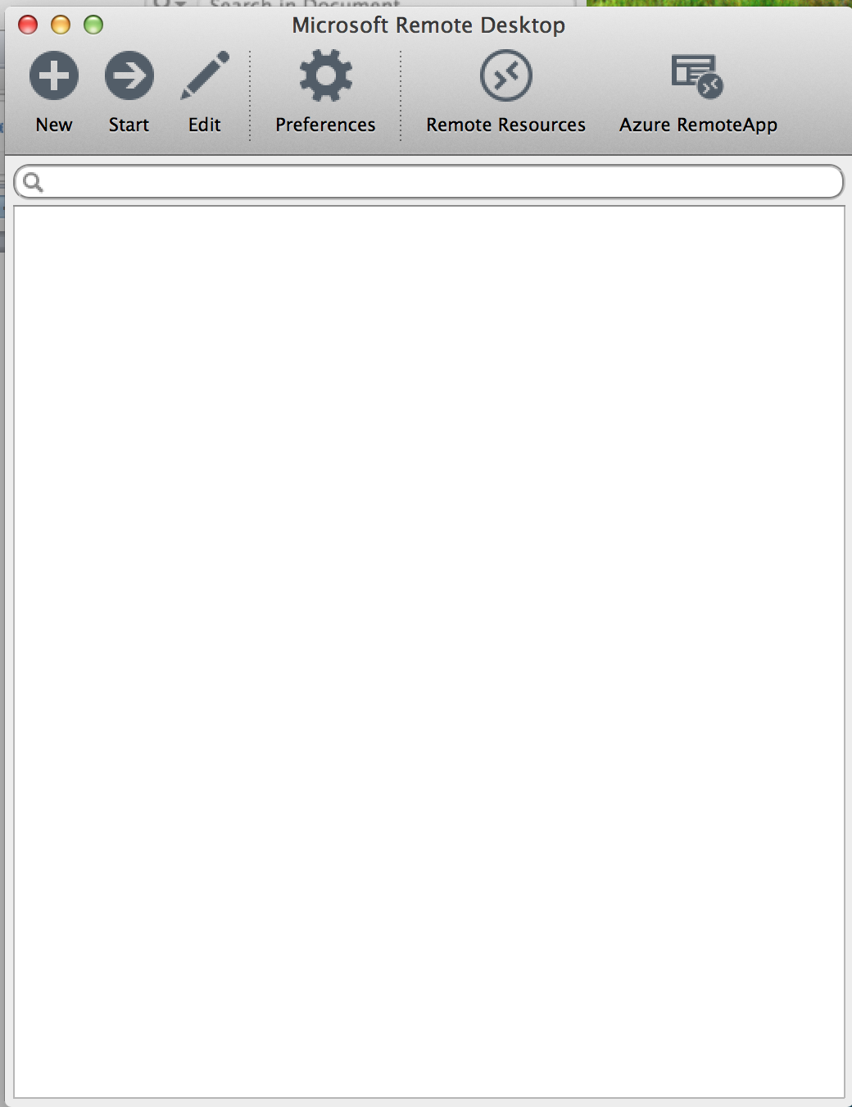

Step 2: Click on the “New” button to add your instance.

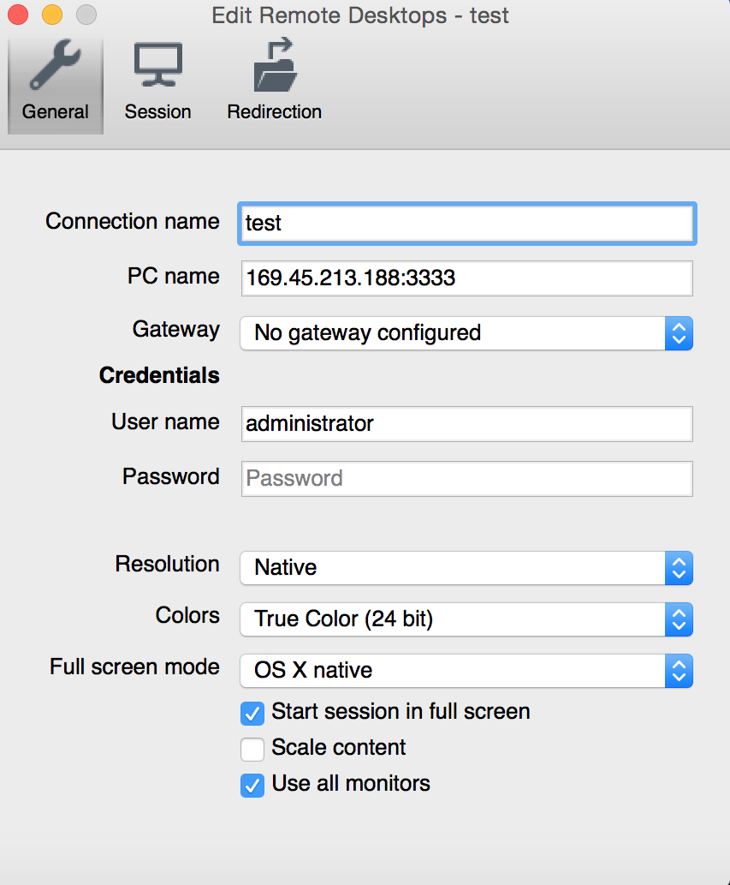

Step 3: Enter the Connection name such as Test.
Step 4: Enter the IP address (and port # if applicable) in the PC Name.
Step 5: Click File > Close. It should now show up in the main window’s My Desktops area.

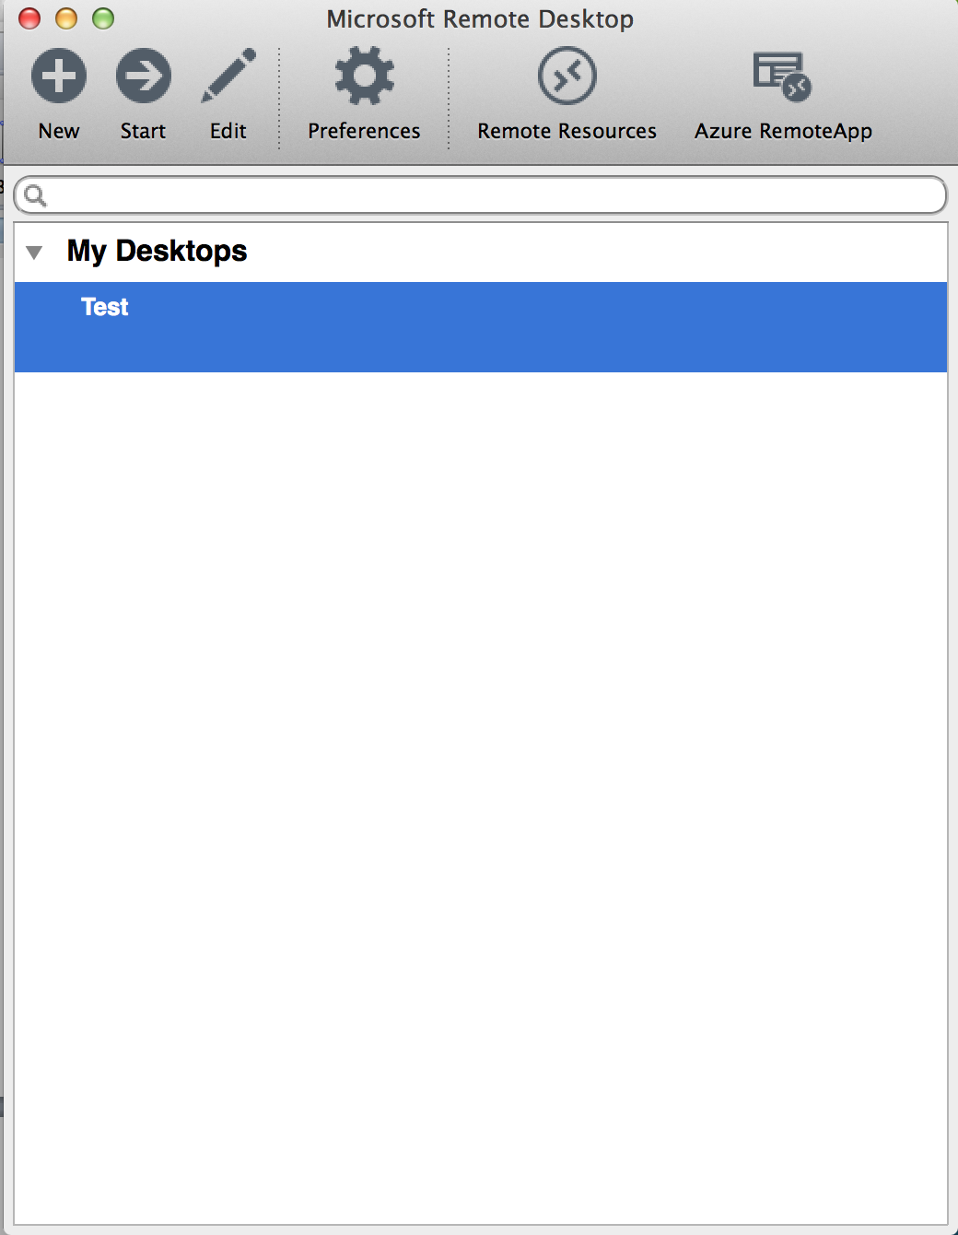

Step 6: Double click on the connection name to connect to the system.

